ArcGIS Enterprise: Roadmap to Enterprise 11.x

Prepared By:
Noe Diaz

Document Release: Version 1.0
March 18, 2024

Obtaining Copies or Requesting Changes
If you need copies of this document or would like to request changes, send an email message on Github.

This page is intentionally left blank.
Revision History
The table that follows summarizes the revision history of this document.
Release | Summary of Revisions | Date | Author(s) | Approver
Draft 0.1 | Draft content created | 01/10/2024 | Noe Diaz | N/A
Draft 0.2 | Technical edit and formatting | 03/18/2024 | Noe Diaz | N/A
Draft 0.3 | Updated draft |  |  | N/A
Draft 0.4 | Technical edits from peer review |  |  | N/A
Draft 0.5 | Content edits |  |  | N/A
Draft 0.6 | Content corrections |  |  | N/A
Draft 0.7 | Quality assurance review |  |  | N/A
Final 1.0 | Accepted edits and baselined the document |  |  | N/A

Contents
Section 1 – Introduction 1
1.1 Purpose 1
1.2 Scope 1
1.3 Document Conventions 1
Section 2 – About This Guide 2
Section 3 – What’s new in Enterprise 11.x 3
3.1 Migration to 10.9.1? 3
3.1.1 Migration tooling to help transition from ArcMap-based to ArcGIS Pro-based runtime 3
3.1.2 Optional Arcmap Runtime Support feature 3
3.1.3 ArcGIS Storymaps, ArcGIS Dashboards, and ArcGIS Instant Apps 4
3.2 Here are the Changes coming in Enterprise 11 4
3.2.1 Move of ArcGIS Enterprise SDK to .Net 6 4
3.2.2 Removal of classic Esri Story Map templates 4
3.2.3 Removal of the Arcmap-based runtime 5
3.2.4 Removal of ArcGIS Dashboards Classic 5
3.2.5 Removal of Presentation for Map Viewer Classic 6
3.2.6 Removal of many Configurable App Templates 6
Section 4 – ArcGIS Enterprise Upgrade Outline 7
4.1 Preliminary Assessment and Planning (OCT-DEC) 7
4.1.1 Preliminary Assessment 7
4.1.2 Current System Evaluation 7
4.1.3 Business Impact Analysis 7
4.1.4 Budget and Resource Planning 7
4.2 Data and Database Backup (Jan – Mar) 8
4.2.1 Data Inventory and Prioritization 8
4.2.2 Backup Methodology Definition 8
4.2.3 Testing and Validation 8
4.2.4 Database Backup 8
4.2.5 Communication and Documentation 8
4.3 Data and Database Backup (APR-JUN) 8
4.3.1 Define Test Environment Objectives 8
4.3.2 Test Environment Procurement 8
4.3.3 Data Migration and Configuration 8
4.3.4 Customization and Application Deployment 9
4.3.5 Performance and User Acceptance Training 9
4.4 Production Upgrade (JUL-SEP) 9
4.4.1 Downtime Scheduling 9
4.4.2 Backup Production Data 9
4.4.3 Execute Upgrade Process 9
4.4.4 Data Integrity Checks and User Access Restoration 9
4.4.5 Communication and Post-Upgrade Validation 9
4.5 Post Upgrade Validation & Documentation (OCT-DEC) 9
4.5.1 Comprehensive System Testing 9
4.5.2 Documentation Update 10
4.5.3 User Training and Knowledge Transfer 10
4.5.4 Continuous Monitoring Implementation 10
4.5.5 Post Upgrade Review Meeting 10
Section 5 – Preliminary Assessment Details 11
5.1.1 Establish Project Team 11
5.1.2 Current State Assessment 11
5.1.3 Stakeholder Interviews 11
5.1.4 Customization and Integration Analysis 11
5.1.5 Identify High-Impact Workflows 12
5.1.6 Risk Assessment 12
5.1.7 Documentation 12
5.1.8 Budget and Resource Planning 12
5.1.9 Preliminary Communication Plan 12
5.1.10 Project Kickoff Meeting 12
Section 6 – System Requirements and Compatibility 13
6.1.1 Review ArcGIS Enterprise 11.x System Requirements 13
6.1.2 Hardware Compatibility Assessment 13
6.1.3 Software Compatibility Check 13
6.1.4 Database Compatibility 13
6.1.5 Review ArcGIS Client Compatibility 13
6.1.6 Third-Party Software and Integrations 14
6.1.7 Security and Authentication Review 14
6.1.8 Licensing Assessment 14
6.1.9 Develop a Compatibility Matrix 14
6.1.10 Mitigation Strategies 19
6.1.11 Communication of Compatibility Findings 19
Section 7 – Data and Database Backup 20
7.1.1 Data Inventory 20
7.1.2 Determine Backup Frequency 20
7.1.3 Select Backup Methodology 20
7.1.4 Backup Testing 20
7.1.5 Database Backup 20
7.1.6 Archive Configuration Files 20
7.1.7 Offsite Storage Consideration 21
7.1.8 Coordinate with Database Administrators 21
7.1.9 Document Backup Schedule 21
7.1.10 Contingency Planning 21
7.1.11 Communication of Backup Plans 21
7.1.12 Monitor and Review Backup Logs 21
Section 8 – Test Environment Setup 22
8.1.1 Define Test Environment Objectives 22
8.1.2 Procure Test Environment Resources 22
8.1.3 Environment Isolation 22
8.1.4 Data Migration to Test Environment 22
8.1.5 Software Installation and Configuration 22
8.1.6 Software Installation and Configuration 23
8.1.7 Customization and Application Deployment 23
8.1.8 Test Data and Workflows 23
8.1.9 Performance Testing 23
8.1.10 User Acceptance Testing (UAT) 23
8.1.11 Identify and Document Issues 24
8.1.12 Iterative Testing and Resolution 25
8.1.13 Test Environment Validation 25
8.1.14 Stakeholder Review 25
8.1.15 Documentation of Test Environment Configuration 25
8.1.16 Test Environment Cleanup 25
Section 9 – User Training and communication 26
9.1.1 Develop Training Materials 26
9.1.2 Training Plan Development 26
9.1.3 Training Sessions for Administrators 26
9.1.4 End-User Training 26
9.1.5 Training Workshops and Q&A Sessions 26
9.1.6 Online Learning Resources 27
9.1.7 Establish a Helpdesk or Support System 27
9.1.8 Communication Plan Execution 27
9.1.9 User Feedback Collection 27
9.1.10 Address User Concerns 27
9.1.11 Internal Documentation 27
9.1.12 Change Management 27
9.1.13 Schedule Refresher Sessions 27
9.1.14 Communication of Upgrade Schedule 28
9.1.15 Post Upgrade Support 28
Section 10 – Customization and Application Updates 29
10.1.1 Customization Inventory 29
10.1.2 Vendor and Third-Party Application Compatibility 29
10.1.3 Review ArcGIS Enterprise 11 Release Notes 29
10.1.4 Update Custom Scripts and Code 29
10.1.5 Application Code and Configuration Updates 29
10.1.6 Web Service Compatibility 30
10.1.7 Test Customizations in the Test Environment 30
10.1.8 Identify and Resolve Issues 30
10.1.9 Validate Third-Party Integrations 30
10.1.10 Documentation Update 30
10.1.11 Communication with Developers 30
10.1.12 Version Control and Backup 30
10.1.13 Regression Testing 31
10.1.14 User Acceptance Training for Custom Applications 31
10.1.15 Obtain User Feedback and Address Concerns 31
10.1.16 Deployment Plan 31
10.1.17 Communication of Customization Updates 31
Section 11 – Production Upgrade 32
11.1.1 Schedule Downtime and Maintenance Window 32
11.1.2 Backup Production Data 32
11.1.3 Notify Stakeholders 32
11.1.4 Disable Services and Access 32
11.1.5 Execute Upgrade Process 32
11.1.6 Validate Post Upgrade State 32
11.1.7 Data Integrity Checks 33
11.1.8 Monitor System Performance 33
11.1.9 Conduct Functional Testing 33
11.1.10 Verify Licensing and Permissions 33
11.1.11 Rollback Plan Activation (If needed) 33
11.1.12 Communication during Upgrade 33
11.1.13 Post Upgrade Verification 33
11.1.14 User Access Restoration 33
11.1.15 Monitor and Address Post-Upgrade Issues 34
11.1.16 Documentation Update 34
11.1.17 Post-Upgrade Review Meetings 34
11.1.18 Communication of Completion 34
Section 12 – Post Upgrade Validation 36
12.1.1 Comprehensive System Testing 36
12.1.2 Workflow Testing 36
12.1.3 Application and Customization Validation 36
12.1.4 Performance Monitoring 36
12.1.5 Data Validation 36
12.1.6 User Access and Permissions Check 36
12.1.7 Compatibility with Third Party Integrations 37
12.1.8 Post Upgrade Regression Testing 37
12.1.9 Addressing Post Upgrade Issues 37
12.1.10 User Feedback Collection 37
12.1.11 Documentation Update 37
12.1.12 Communication of Post Upgrade Status 37
12.1.13 Performance Optimization 37
12.1.14 Training and Support Continuation 37
12.1.15 Security and Compliance Checks 38
12.1.16 Conitnious Monitoring 38
12.1.17 Post-Upgrade Review Meetings 38
12.1.18 Communication of Completion 38
Section 13 – Documentation and Knowledge Transfer 39
13.1.1 Documentation Update 39
13.1.2 System Architecture Documentation 39
13.1.3 Configuration Changers and Best Practices 39
13.1.4 User Guides and Training Materials 39
13.1.5 Troubleshooting Procedures 40
13.1.6 Knowledge Transfer Sessions 40
13.1.7 Hands-on Workshops 40
13.1.8 Training for New Features 40
13.1.9 Support System Documentation 40
13.1.10 Maintenance and Upgrade Scheduling 40
13.1.11 Disaster Recovery and Backup Documentation 40
13.1.12 Internal Knowledge Base 41
13.1.13 Training and Documentation Review 41
13.1.14 Certification and Recognition 41
13.1.15 Continuous Improvement Plan 41
13.1.16 Continuous of Documentation Completion 41
Section 14 – Ongoing monitoring and Optimization 42
14.1.1 Establish Monitoring Framework 42
14.1.2 Set up Alerts and Notifications 42
14.1.3 Performance Metrices Monitoring 42
14.1.4 User Activity Analysis 42
14.1.5 Capacity Planning 42
14.1.6 Regular System Audits 43
14.1.7 Database Maintenance 43
14.1.8 Log Analysis 43
14.1.9 Continuous Security Monitoring 43
14.1.10 Regular Patching and Updates 43
14.1.11 User Feedback Collection 43
14.1.12 Performance Optimization Iterations 43
14.1.13 Documentation Update 44
14.1.14 Periodic Review Meetings 44
14.1.15 Disaster Recovery Drills 44
14.1.16 Regular Training and Support 44
14.1.17 Stakeholder Communication 44
14.1.18 Continuous Improvement Plan 44
Appendix A – References A-1

Introduction

Purpose
This installation guide provides the information necessary to understanding the roadmap to upgrading your ArcGIS Enterprise.

Scope
This document covers all required steps for understanding how to migrate to a new ArcGIS Enterprise.

About This Guide
The content in this installation guide contains references to the software manufacturer’s online help documentation specific to ArcGIS Enterprise Roadmap to Enterprise 11.x. These help topics are noted, where applicable, and the links to the specific topics are in alphabetical order in Appendix A.

What’s new in Enterprise 11.x
Upgrading to ArcGIS Enterprise 11.0 will require a bit more preparation than previous upgrades. This release will be the first time we have increased the major version number of ArcGIS Server, now part of ArcGIS Enterprise, since ArcGIS 10.0 was released in 2010.
i | Note: With all the changes to anticipate in ArcGIS Enterprise 11.0, the prospect of upgrading may feel a bit more daunting than usual – and that’s okay! While upgrades from ArcGIS Enterprise 10.7 to 11.0 will be supported, this whole process doesn’t have to be daunting; consider upgrading to Enterprise 10.9.1 before making the upgrade to 11.0. There are a few reasons to consider upgrading to ArcGIS Enterprise 10.9.1 before 11.0.

Migration to 10.9.1?

Migration tooling to help transition from ArcMap-based to ArcGIS Pro-based runtime
ArcGIS Enterprise 10.9 and 10.9.1 has migration tooling to help ease your transition to the ArcGIS Pro-based runtime. These migration tools include:
Edit Runtime operation – this operation is available through ArcGIS Server Manager and allows for compatible service runtimes to be migrated one at a time.
UpdateArcMapServices utility – this utility is a command line utility that comes installed with ArcGIS Server and allows for compatible service runtimes to be analyzed and to be migrated all at once.
These migration tools migrate all compatible map and image services. In 10.9.1 we also introduced the ability to migrate geodata services as well through these migration tools.
To learn more about the migration tooling introduced in 10.9, be sure to check out the blog on migrating services to the ArcGIS Pro-based runtime in ArcGIS Enterprise. Also visit the technical paper for more information on manually migrating your services: Manually migrating services from the ArcMap-based to the ArcGIS Pro-based runtime (pdf).

Optional Arcmap Runtime Support feature
In ArcGIS Enterprise 10.9.1 we introduced the ability to disable the ArcMap Runtime Support feature. This means you can remove the ArcMap-based runtime from ArcGIS Server. This is ideal if your organization fits into one of two criteria:
You need to remove Python 2.x from your system or you are ready to migrate fully to the ArcGIS Pro-based runtime.
More on this can be found in our blog: ArcMap Runtime Support: to disable or not to disable?

ArcGIS Storymaps, ArcGIS Dashboards, and ArcGIS Instant Apps
ArcGIS Enterprise 10.9.1 is the only release to include Esri Story Map classic templates, ArcGIS Dashboards Classic, and all of the ArcGIS Configurable apps side by side ArcGIS StoryMaps, ArcGIS Dashboards, and ArcGIS Instant Apps. Take advantage of all of these applications being in one release by being able to create new apps in the same organization as your old ones – meaning you’ll be ready to go when upgrading to ArcGIS Enterprise 11.0.

Here are the Changes coming in Enterprise 11
This section describes the changes that are more applicable to GeoState’s environment.

Move of ArcGIS Enterprise SDK to .Net 6
ArcGIS Enterprise 10.9.1 is the last release to support .NET Framework 4.x-based SOEs and SOIs. ArcGIS Enterprise 11.0 will support .NET 6.
If you are using .NET Framework-based SOEs and SOIs, begin planning for a move to .NET 6 at this time by identifying any .NET core library changes that will affect existing solutions as well as finding .NET 6 versions of any third-party libraries that are used.
The APIs exposed in the ArcGIS Enterprise SDK will include some minor breaking changes in addition to the move to .NET 6. Your use of ArcGIS Enterprise SDK APIs will also need to be reviewed when moving to ArcGIS Enterprise 11.0. These API changes will impact both .NET and Java-based extensions. Any development impact related to these API changes is expected to be minimal, but all extensions will at minimum need to be recompiled for 11.0. If you have extensions from partners or other external suppliers, you will need to get updated extensions from them.

Removal of classic Esri Story Map templates
ArcGIS Enterprise 10.9.1 is the last version to include classic Esri Story Maps templates for both authoring new story maps and for viewing existing story maps created using these templates. ArcGIS Enterprise 11.0 will no longer include the ability to create new classic Esri Story Maps nor view existing Story Maps created with the classic templates.
If your organization is using one of the classic templates, be sure to upgrade your stories to current-generation products prior to upgrading. For classic stories that are still in active use, we recommend recreating them with ArcGIS StoryMaps.
Several resources exist to help you make the switch to ArcGIS StoryMaps:
Moving to the new ArcGIS StoryMaps : a helpful guide for transitioning
Getting started with ArcGIS StoryMaps : a step-by-step tutorial for beginners
Discover the possibilities with ArcGIS StoryMaps! : a collection of over a dozen articles and tutorials
Recreating a classic story with ArcGIS StoryMaps : a look at how to give a classic story new life
If you upgrade to ArcGIS Enterprise 11.0 with a classic Story Map template present, the item will show up in your Content with a “Retired” badge. Though you can view the item, you will no longer be able to access the application.

Removal of the Arcmap-based runtime
The removal of the ArcMap-based runtime is one of the biggest changes coming in ArcGIS Enterprise 11.0. In version 10.9.1 and earlier, the ArcGIS Server component includes two internal runtimes: an ArcMap-based runtime for services published from ArcMap and an ArcGIS Pro-based runtime for services published from ArcGIS Pro. ArcGIS Enterprise 11.0 will be the first release to only include the ArcGIS Pro-based runtime, meaning it will no longer be possible to publish new services using ArcMap or run services that are using the ArcMap-based runtime. It will also no longer be possible to administer ArcGIS Server using ArcMap or ArcCatalog. More background on this topic can be found in our Removal of the ArcMap-based runtime from ArcGIS Enterprise blog.
If you upgrade to ArcGIS Enterprise 11.0 with ArcMap-based services present, compatible ArcMap-based services will be migrated to the ArcGIS Pro-based runtime during the upgrade. ArcMap-based services that can’t be automatically migrated will be stopped after an upgrade to 11.x and will require additional work. Compatible services include map services, feature services image services, and geodata services. Non-compatible services include services using deprecated data sources or with ArcObjects-based Server Object Extensions (SOEs) and Server Object Interceptors (SOIs), geocode services, geoprocessing services, network analysis services, and schematics services. These services will need to be manually migrated to the ArcGIS Pro-based runtime. For more information on this, see the Manually migrating services from the ArcMap-based to the ArcGIS Pro-based runtime tech paper (pdf).

Removal of ArcGIS Dashboards Classic
Similar to classic Esri Story Map templates, ArcGIS Enterprise 10.9.1 is the last version to include ArcGIS Dashboards Classic in favor of the new version of ArcGIS Dashboards that provides the same functionality but is more performant, scales to handle high demand, leverages the latest and greatest mapping innovations, and includes new data visualizations, including tables, and features such as advanced formatting, data expressions, and more.
Though you won’t notice much of a change when ArcGIS Dashboards Classic is retired, because your existing dashboards will continue to just work and upgrade themselves, starting with ArcGIS Enterprise 11.0, you will no longer be able to create or edit dashboards with ArcGIS Dashboards Classic. More on this can be found in our ArcGIS Dashboards Classic is Retiring blog.

Removal of Presentation for Map Viewer Classic
ArcGIS Enterprise 10.9.1 is the last version to include Presentation for Map Viewer Classic. Presentation for Map Viewer Classic has been superseded by Exhibit, an ArcGIS Instant App that will be introduced with ArcGIS Enterprise 11.0. It is recommended that all existing presentations be retired before upgrading to ArcGIS Enterprise 11.0.

Removal of many Configurable App Templates
ArcGIS Enterprise 10.9.1 is the last release to include all Configurable App Templates. Starting with ArcGIS Enterprise 11.0, all Configurable App Templates with the exception of those listed below will be retired and removed from ArcGIS Enterprise.
Available in ArcGIS Enterprise 11.0:
- Basic Viewer
- Compare
- Crowdsource Manager
- Crowdsource Polling
- Crowdsource Reporter
- GeoForm
- Image Mask
- Image Visit
Similar to the classic Story Map templates, if you upgrade to ArcGIS Enterprise 11.0 with one of the retired Configurable Apps present, the item will show up in your Content with a “Retired” badge. Though you can view the item, you will no longer be able to access the application. The templates that are still supported will continue functioning the same as in previous versions.

ArcGIS Enterprise Upgrade Outline

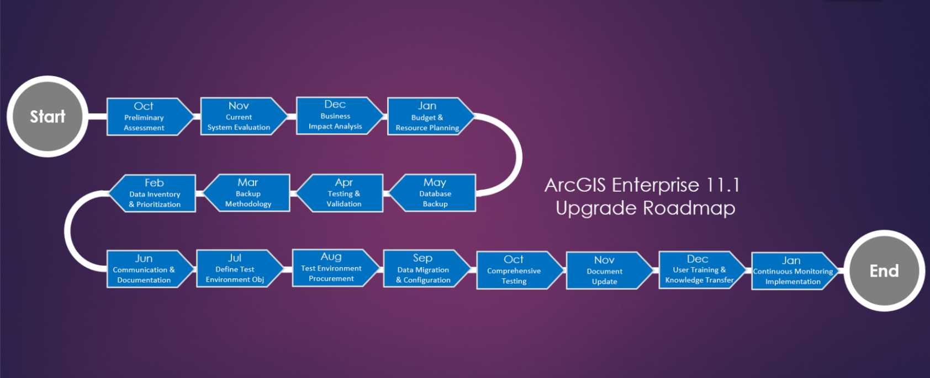
Preliminary Assessment and Planning (OCT-DEC)

Preliminary Assessment
- Establish the Geospatial Governance Board.
- Define project objectives, scope, and success criteria.
- Identify key stakeholders and establish communication channels.

Current System Evaluation
- Conduct an assessment of the existing ArcGIS Enterprise deployment.
- Review hardware and software specifications.
- Identify customizations, applications, and third-party integrations.

Business Impact Analysis
- Evaluate the potential business impact of the upgrade.
- Identify critical workflows and user dependencies.

Budget and Resource Planning
- Estimate the budget for the upgrade project.
- Plan resource allocation, including personnel and infrastructure.

Data and Database Backup (Jan – Mar)

Data Inventory and Prioritization
- Create an inventory of GIS data.
- Prioritize datasets based on business importance.

Backup Methodology Definition
- Define the frequency and methodology for data backups.
- Choose between full, incremental, or snapshot-based backups.

Testing and Validation
- Perform test backups to validate the process.
- Document steps for data restoration.

Database Backup
- Back up ArcGIS Enterprise geodatabases and associated databases.
- Archive configuration files.

Communication and Documentation
- Communicate backup plans to stakeholders.
- Document backup schedules and procedures.

Data and Database Backup (APR-JUN)

Define Test Environment Objectives
- Clearly define objectives for the test environment.
- Identify critical workflows and applications for testing.

Test Environment Procurement
- Acquire necessary hardware, software, and licenses.
- Isolate the test environment from production.

Data Migration and Configuration
- Migrate a copy of production data to the test environment.
- Install and configure ArcGIS Enterprise 11.1.

Customization and Application Deployment
- Deploy custom scripts, applications, and web services.
- Test customizations for compatibility.

Performance and User Acceptance Training
- Conduct performance testing.
- Engage end-users in user acceptance testing.

Production Upgrade (JUL-SEP)

Downtime Scheduling
- Schedule planned downtime for production upgrade.
- Notify stakeholders about the upgrade schedule.

Backup Production Data
- Perform a final backup of production data.
- Disable services and access.

Execute Upgrade Process
- Follow the documented upgrade process.
- Validate post-upgrade state.

Data Integrity Checks and User Access Restoration
- Conduct data integrity checks.
- Restore user access after a successful upgrade.

Communication and Post-Upgrade Validation
- Provide real-time updates during the upgrade.
- Conduct post-upgrade validation and address any issues.

Post Upgrade Validation & Documentation (OCT-DEC)

Comprehensive System Testing
- Conduct comprehensive testing of ArcGIS Enterprise 11.1.
- Validate workflows and applications.

Documentation Update
- Update system documentation.
- Include changes, configurations, and resolutions.

User Training and Knowledge Transfer
- Conduct knowledge transfer sessions.
- Organize hands-on workshops and refresher training.

Continuous Monitoring Implementation
- Establish a comprehensive monitoring framework.
- Set up alerts and notifications.

Post Upgrade Review Meeting
- Review post-upgrade results with stakeholders.
- Discuss lessons learned and areas for improvement.

Preliminary Assessment Details
Step 1, the Preliminary Assessment phase, is a crucial starting point to understand the current state of your ArcGIS Enterprise deployment and set the foundation for the upgrade process. Here are more detailed steps for this phase:
- Establish a project team consisting of GIS administrators, IT personnel, and key stakeholders.
- Conduct a thorough review of the current ArcGIS Enterprise deployment (hardware, software, licenses).
- Identify existing customizations, applications, and workflows that may be impacted by the upgrade.

Establish Project Team
- Identify key stakeholders from different departments, including GIS administrators, IT personnel, and representatives from relevant business units.
- Define roles and responsibilities within the project team to ensure clear accountability.

Current State Assessment
- Conduct a detailed review of the existing ArcGIS Enterprise deployment, including:
- Version of ArcGIS Enterprise currently in use.
- Hardware specifications (servers, storage, etc.).
- Software components (ArcGIS Server, Portal for ArcGIS, ArcGIS Data Store, etc.).
- Licensing details (versions, expiry dates, license levels).
- Identify any patches or updates that have been applied.

Stakeholder Interviews
- Schedule interviews with key stakeholders to gather insights into current pain points, challenges, and desired improvements.
- Document specific use cases, workflows, and business requirements related to GIS.

Customization and Integration Analysis
- Identify and document any customizations, scripts, or applications built on top of ArcGIS Enterprise.
- Assess third-party integrations and dependencies.

Identify High-Impact Workflows
- Prioritize critical business workflows that heavily depend on ArcGIS Enterprise.
- Determine how these workflows may be impacted by the upgrade.

Risk Assessment
- Conduct a preliminary risk assessment to identify potential challenges and obstacles.
- Assess the impact of the upgrade on existing projects and ongoing initiatives.

Documentation
- Review existing documentation related to ArcGIS Enterprise, including system architecture diagrams, deployment guides, and standard operating procedures.

Budget and Resource Planning
- Estimate the budget and resources required for the upgrade project.
- Identify any potential procurement needs for hardware, software, or consulting services.

Preliminary Communication Plan
- Develop a high-level communication plan outlining how and when information about the upgrade will be shared with stakeholders.
- Consider creating a project website or a central communication hub for updates.

Project Kickoff Meeting
- Conduct a kickoff meeting to officially launch the upgrade project.
- Present the findings of the preliminary assessment to the Geospatial Governance Board and gather their input.
This comprehensive preliminary assessment will provide a solid foundation for the subsequent steps in the upgrade roadmap, ensuring that the upgrade plan is tailored to the specific needs and challenges of your organization. Regular communication and collaboration with stakeholders during this phase are key to success.

System Requirements and Compatibility
Step 2, the System Requirements and Compatibility Check phase, involves reviewing and ensuring that the existing infrastructure is compatible with the new ArcGIS Enterprise 11.1 version. Here are more detailed steps for this phase:
- Review ArcGIS Enterprise 11.1 system requirements.
- Assess the compatibility of existing applications, databases, and third-party integrations.
- Identify and address any hardware or software upgrades needed for compatibility.

Review ArcGIS Enterprise 11.x System Requirements
- Access the official ArcGIS Enterprise documentation for version 11.1 and thoroughly review the system requirements.
- Identify changes in hardware, software, and operating system requirements compared to the current deployment.

Hardware Compatibility Assessment
- Evaluate the existing hardware infrastructure to determine if any upgrades are necessary.
- Ensure that servers, storage, and network components meet or exceed the requirements specified for ArcGIS Enterprise 11.1.

Software Compatibility Check
- Verify the compatibility of the existing operating systems, web browsers, and database management systems with ArcGIS Enterprise 11.1.
- Identify any required software updates or patches for compatibility.

Database Compatibility
- Check the compatibility of the current database management system (e.g., PostgreSQL, SQL Server, Oracle) with ArcGIS Enterprise 11.1.
- Plan for any necessary database upgrades or migrations.

Review ArcGIS Client Compatibility
- Assess the compatibility of ArcGIS Desktop, ArcGIS Pro, and other client applications with the new version.
- Identify any necessary client-side updates or configurations.

Third-Party Software and Integrations
- Evaluate the compatibility of third-party software applications and integrations with ArcGIS Enterprise 11.1.
Communicate with vendors to ensure that any integrations or dependencies are supported.

Security and Authentication Review
- Review the security enhancements and changes in authentication mechanisms introduced in ArcGIS Enterprise 11.1.
- Ensure that existing security configurations align with best practices for the new version.

Licensing Assessment
- Review the licensing changes in ArcGIS Enterprise 11.1.
- Verify the availability and validity of licenses for the new version.
- Plan for license upgrades or renewals if necessary.

Develop a Compatibility Matrix
Create a comprehensive compatibility matrix that outlines the compatibility status of each component, including hardware, software, databases, clients, and integrations.
See below for functionality matrix of similarities and contrast between both enterprises. 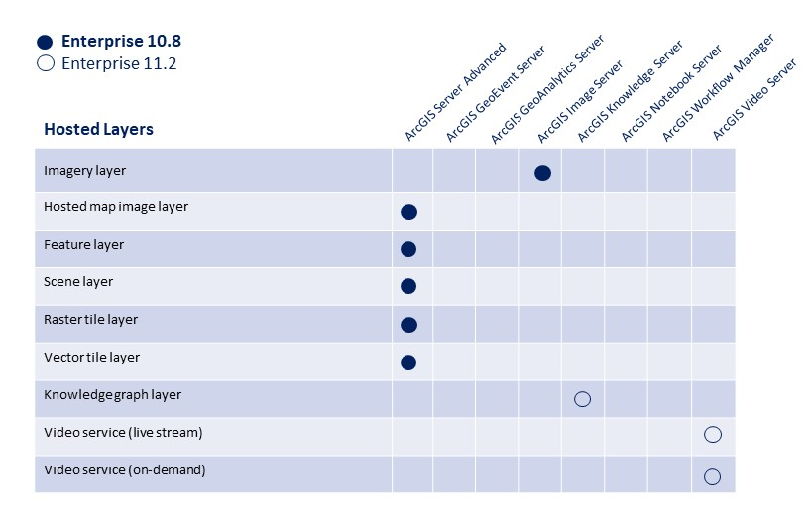
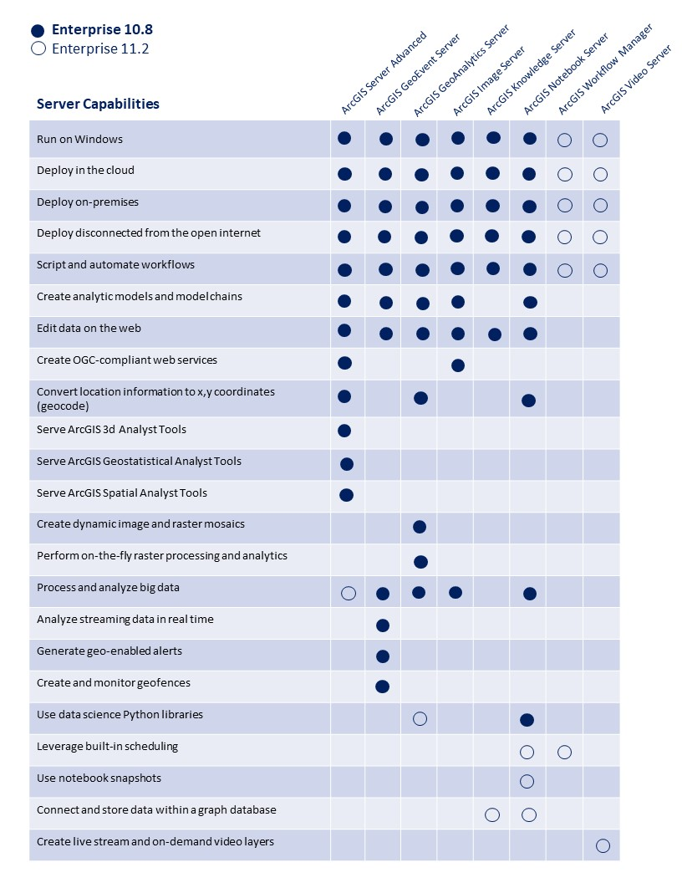
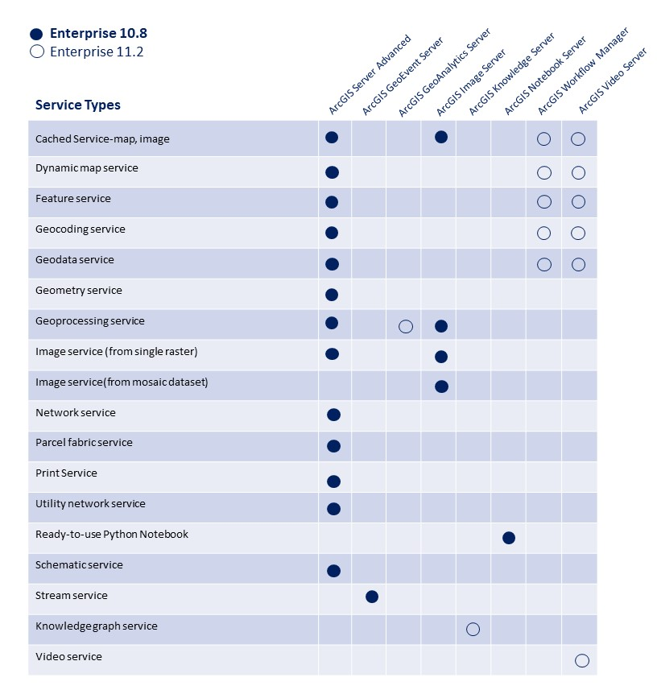
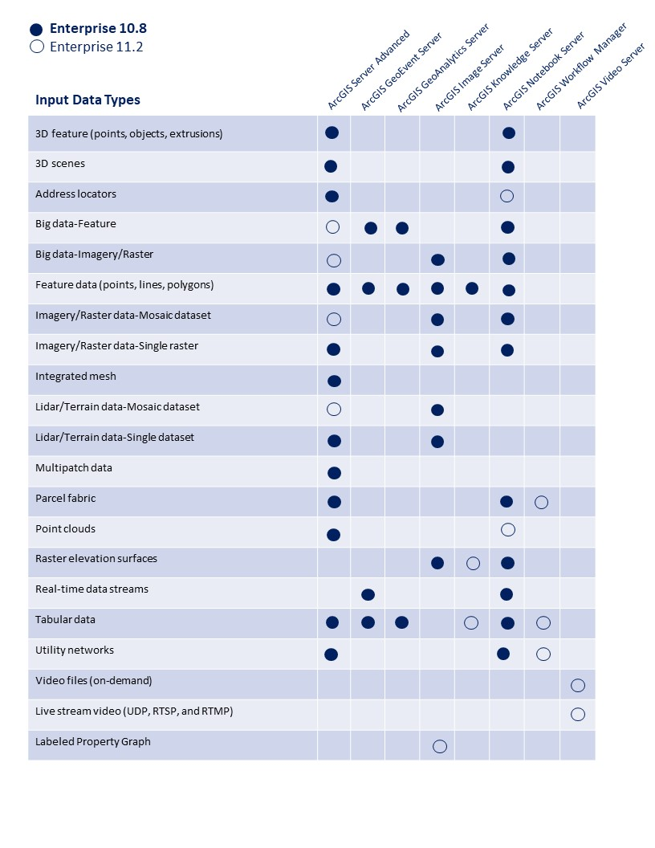
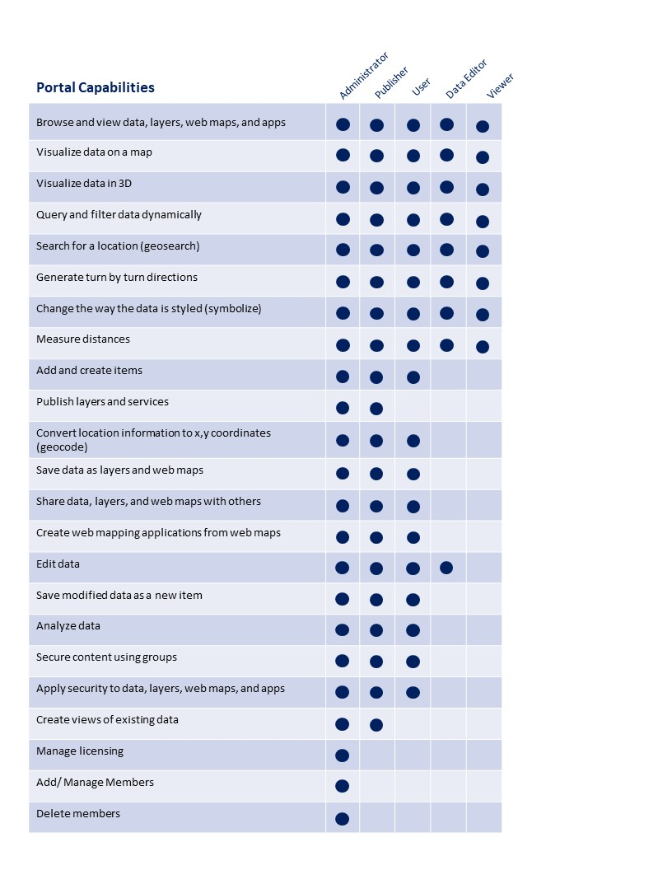

Mitigation Strategies
- Identify potential compatibility issues and develop mitigation strategies.
- Plan for contingency measures in case any issues arise during the upgrade process.

Communication of Compatibility Findings
- Communicate the compatibility findings to the Geospatial Governance Board and key stakeholders.
- Share the compatibility matrix and outline any actions that need to be taken to ensure a smooth upgrade.
This phase is critical for ensuring that the organization's infrastructure is ready for the ArcGIS Enterprise 11.1 upgrade. Addressing compatibility issues proactively will minimize the risk of disruptions during the actual upgrade process. Regular updates and collaboration with stakeholders will be essential during this phase as well.

Data and Database Backup
Step 3, the Data and Database Backup phase, involves implementing a robust backup strategy to ensure the safety and integrity of GIS data during the ArcGIS Enterprise 11.1 upgrade. Here are more detailed steps for this phase:
- Implement a comprehensive backup strategy for GIS data and databases.
- Test the backup and restoration process to ensure data integrity.

Data Inventory
- Create an inventory of all GIS data, including feature datasets, tables, and associated files.
- Identify critical datasets and prioritize them based on business importance.

Determine Backup Frequency
- Define the frequency of data backups based on the organization's data update frequency and criticality.
- Consider daily or incremental backups leading up to the upgrade.

Select Backup Methodology
- Choose an appropriate backup methodology, considering options such as full backups, incremental backups, or snapshot-based backups.
- Ensure that the selected methodology aligns with data recovery objectives.

Backup Testing
- Perform test backups to validate the backup process and ensure that data can be successfully restored.
- Document the steps involved in data restoration.

Database Backup
- Back up the ArcGIS Enterprise geodatabases and associated databases.
- Include metadata databases, configuration databases, and any other databases used by ArcGIS Enterprise components.

Archive Configuration Files
- Archive configuration files related to ArcGIS Enterprise, including server configurations, portal configurations, and any custom settings.
- Document the location of these configuration files for reference during the upgrade.

Offsite Storage Consideration
- If feasible, consider storing backups in an offsite location to mitigate risks associated with on-site disasters.
- Ensure that offsite storage complies with organizational policies and data security requirements.

Coordinate with Database Administrators
- Collaborate with database administrators to coordinate the backup process, ensuring that database-specific considerations are addressed.
- Confirm database backup schedules and procedures.

Document Backup Schedule
- Create a backup schedule that clearly outlines the timing, frequency, and duration of data backups leading up to the upgrade.
- Share this schedule with relevant stakeholders.

Contingency Planning
- Develop contingency plans for unforeseen circumstances during the upgrade.
- Establish procedures for quick data restoration in the event of an unexpected issue.

Communication of Backup Plans
- Communicate the backup plans and schedules to the Geospatial Governance Board, GIS administrators, and other relevant stakeholders.
- Highlight the importance of data integrity and the organization's commitment to minimizing potential data loss.

Monitor and Review Backup Logs
- Implement a monitoring system to track and review backup logs regularly.
- Ensure that backups are successful and identify and address any issues promptly.
Implementing a comprehensive data and database backup strategy is crucial for safeguarding GIS data during the ArcGIS Enterprise 11.1 upgrade. Regular communication and collaboration with database administrators and key stakeholders will contribute to a smooth and reliable backup process.

Test Environment Setup
Step 4, the Test Environment Setup phase, involves creating a dedicated test environment to mirror the production environment for thorough testing of the ArcGIS Enterprise 11.1 upgrade. Here are more detailed steps for this phase:
- Establish a dedicated test environment mirroring the production environment.
- Migrate the current ArcGIS Enterprise setup to the test environment.
- Conduct thorough testing of applications, customizations, and workflows.

Define Test Environment Objectives
- Clearly define the objectives of the test environment, specifying what aspects of the ArcGIS Enterprise deployment will be tested.
- Identify critical workflows, applications, and customizations for testing.

Procure Test Environment Resources
- Acquire the necessary hardware, software, and licenses to set up a dedicated test environment.
- Ensure that the test environment closely matches the production environment in terms of specifications.

Environment Isolation
- Isolate the test environment from the production environment to prevent any unintended impact on live data or services.
- Use separate servers, databases, and network configurations for testing.

Data Migration to Test Environment
- Migrate a copy of production data to the test environment to simulate real-world conditions.
- Include representative datasets and configurations to accurately replicate production scenarios.

Software Installation and Configuration
- Install ArcGIS Enterprise 11.1 on the test environment servers.
- Configure ArcGIS Server, Portal for ArcGIS, and other components according to the organization's requirements.

Software Installation and Configuration
- Install ArcGIS Enterprise 11.1 on the test environment servers.
- Configure ArcGIS Server, Portal for ArcGIS, and other components according to the organization's requirements.

Customization and Application Deployment
- Deploy custom scripts, applications, and web services to the test environment.
- Test customizations and applications to ensure compatibility with ArcGIS Enterprise 11.1.

Test Data and Workflows
- Execute a series of test cases that cover key data and workflows within the organization.
- Test critical applications and customizations to identify any issues introduced by the upgrade.

Performance Testing
- Conduct performance testing to assess the responsiveness and scalability of the ArcGIS Enterprise 11.1 environment.
- Monitor resource utilization, response times, and system stability under varying loads.

User Acceptance Testing (UAT)
- Engage end-users and stakeholders in UAT activities.
- Gather feedback on the user experience, performance, and functionality of ArcGIS Enterprise 11.x.
User Acceptance Testing (UAT) for ArcGIS Enterprise 11.1 involves testing the system to ensure that it meets the specified requirements and is acceptable for end users. The scope of UAT for ArcGIS Enterprise 11.1 can be divided into two main components: what the team will do and what the users will do.
Team Responsibilities:
1. Test Environment Setup: Configure a test environment that mirrors the production environment where ArcGIS Enterprise 11.x will be deployed.
2. Test Case Development: Define and create test cases based on the requirements and functionality of ArcGIS Enterprise 11.x. Test cases should cover various aspects such as data management, spatial analysis, security features, scalability, and performance.
3. Execution of Test Cases: Execute the test cases in the defined test environment. Monitor and log results, including any deviations from expected behavior.
4. Defect Reporting: Document and report any defects or issues identified during testing. Provide detailed information about the nature of the defects and steps to reproduce them.
5. Collaboration with Development Team: Work closely with the development team to communicate and resolve identified issues. Verify fixes implemented by the development team.
6. Documentation: Maintain documentation related to test cases, test results, and any changes made during the UAT process.
User Responsibilities:
1. User Scenario Testing: Users should perform testing based on real-world scenarios that align with their day-to-day use of ArcGIS Enterprise 11.x.
2. Feedback Submission: Users should provide feedback on the usability, intuitiveness, and overall user experience of the ArcGIS Enterprise 11.x interface.
3. Data Validation: Validate that the data processed and presented by ArcGIS Enterprise 11.x is accurate and meets their expectations.
4. Security Testing: Users should validate the security features, ensuring that access controls and permissions are functioning as intended.
5. Performance Testing: Users should assess the performance of ArcGIS Enterprise 11.x under realistic workloads to ensure it meets performance expectations.
6. Documentation Review: Review user documentation to ensure it is clear, accurate, and helpful.
The goal of UAT is to ensure that ArcGIS Enterprise 11.x not only meets technical requirements but also aligns with user expectations and provides a positive user experience. The collaboration between the testing team and users is crucial to identifying and addressing any issues before the system is deployed in a production environment.

Identify and Document Issues
- Document any issues, errors, or unexpected behavior encountered during testing.
- Categorize issues based on severity and potential impact on production.

Iterative Testing and Resolution
- Address identified issues iteratively, with multiple rounds of testing and resolution.
- Conduct additional testing to ensure that fixes do not introduce new problems.

Test Environment Validation
- Validate that the test environment accurately represents the production environment.
- Confirm that customizations, applications, and workflows behave as expected in the upgraded environment.

Stakeholder Review
- Review the results of the test environment with the Geospatial Governance Board and key stakeholders.
- Discuss any identified issues, their resolutions, and the overall readiness of the system for production upgrade.

Documentation of Test Environment Configuration
- Document the configuration of the test environment, including server specifications, software versions, and customizations.
- Create a comprehensive report summarizing the testing process, identified issues, and resolutions.

Test Environment Cleanup
- Remove test data and configurations from the test environment.
- Ensure that the test environment is properly decommissioned to avoid confusion with the production environment.
Establishing a robust test environment and conducting thorough testing is critical to identifying and resolving potential issues before the production upgrade. Regular communication with stakeholders and transparent reporting on testing outcomes will instill confidence in the upgrade process.

User Training and communication
The User Training and Communication phase, focuses on preparing end-users and stakeholders for the upcoming ArcGIS Enterprise 11.1 upgrade. Effective communication and training are essential to ensure a smooth transition. Here are more detailed steps for this phase:
- Develop training materials for users and administrators on new features and changes.
- Conduct training sessions to familiarize users with ArcGIS Enterprise 11.1.
- Communicate the upcoming upgrade to all stakeholders, highlighting benefits and potential impacts.

Develop Training Materials
- Create comprehensive training materials that cover the new features, changes, and enhancements introduced in ArcGIS Enterprise 11.1.
- Tailor materials to different user roles and their specific needs.

Training Plan Development
- Develop a detailed training plan outlining the schedule, format, and delivery methods for training sessions.
- Consider different modes such as in-person sessions, webinars, documentation, and video tutorials.

Training Sessions for Administrators
- Conduct specialized training sessions for GIS administrators and IT staff responsible for managing and maintaining ArcGIS Enterprise.
- Cover administrative tasks, new configurations, and best practices for the upgraded environment.

End-User Training
- Organize training sessions for end-users based on their roles and responsibilities.
- Emphasize changes to workflows, user interfaces, and any new tools introduced in ArcGIS Enterprise 11.1.

Training Workshops and Q&A Sessions
- Host workshops and Q&A sessions to provide hands-on experience and address user questions.
- Encourage users to bring their workflows or challenges for discussion.

Online Learning Resources
- Develop and provide access to online learning resources, such as video tutorials, documentation, and FAQs, for self-paced learning.
- Ensure that these resources are easily accessible for ongoing reference.

Establish a Helpdesk or Support System
- Set up a helpdesk or support system to address user queries and issues promptly.
- Communicate the contact information and availability of support channels.

Communication Plan Execution
- Execute the communication plan developed during the Preliminary Assessment phase.
- Regularly update stakeholders on the progress of the upgrade and training activities.

User Feedback Collection
- Collect feedback from users during training sessions and after they start using the upgraded system.
- Use surveys, focus groups, or feedback forms to gather insights.

Address User Concerns
- Address user concerns and feedback promptly.
- Provide additional training or documentation if certain topics require clarification.

Internal Documentation
- Create internal documentation outlining the key points covered in training sessions.
- Document any common issues or questions and their resolutions.

Change Management
- Implement change management strategies to help users adapt to the new system.
- Emphasize the benefits of the upgrade and how it aligns with organizational goals.

Schedule Refresher Sessions
- Schedule refresher training sessions after the initial implementation to reinforce key concepts.
- Address any new questions or challenges that arise post-upgrade.

Communication of Upgrade Schedule
- Remind users of the upgrade schedule, downtime, and any expected impacts on their work.
- Provide clear instructions on what actions users need to take, if any, during the upgrade window.

Post Upgrade Support
- Continue to provide support and assistance to users after the upgrade.
- Monitor user adoption and address any lingering issues or concerns.
Effective training and communication are crucial for the success of the upgrade, ensuring that users are well-prepared and comfortable with the changes introduced by ArcGIS Enterprise 11.1. Regular and transparent communication builds trust and reduces resistance to change.

Customization and Application Updates
Step 6, the Customization and Application Updates phase, focuses on updating or modifying existing customizations, applications, and workflows to ensure compatibility with ArcGIS Enterprise 11.1. Here are more detailed steps for this phase:
- Update or modify custom scripts, applications, and web services to be compatible with ArcGIS Enterprise 11.1.
- Work with developers and vendors to ensure third-party applications are compatible.
- Conduct additional testing to validate customizations.

Customization Inventory
- Create an inventory of all existing customizations, scripts, applications, and web services built on or integrated with ArcGIS Enterprise.
- Identify the purpose, functionality, and dependencies of each customization.

Vendor and Third-Party Application Compatibility
- Reach out to vendors or third-party providers of applications and integrations to confirm compatibility with ArcGIS Enterprise 11.1.
- Obtain updated versions or patches if needed.

Review ArcGIS Enterprise 11 Release Notes
- Carefully review the release notes and documentation for ArcGIS Enterprise 11.1.
- Identify changes, deprecations, and new features that may impact existing customizations.

Update Custom Scripts and Code
- Modify or update custom scripts and code to ensure compatibility with the new version.
- Test scripts in the test environment to catch and address any issues.

Application Code and Configuration Updates
- Update the code and configurations of custom applications built on top of ArcGIS Enterprise.
- Address any changes in APIs, libraries, or functionality introduced in ArcGIS Enterprise 11.1.

Web Service Compatibility
- Verify the compatibility of any web services or APIs used in custom applications.
- Modify code as necessary to work seamlessly with ArcGIS Enterprise 11.1 services.

Test Customizations in the Test Environment
- Deploy updated customizations to the test environment and conduct thorough testing.
- Ensure that customizations work as expected and do not introduce errors or performance issues.

Identify and Resolve Issues
- Document and address any issues or errors encountered during testing.
- Work closely with developers to resolve compatibility issues with ArcGIS Enterprise 11.1.

Validate Third-Party Integrations
- Validate third-party integrations in the test environment.
- Confirm that data exchanges and interactions with external systems are not disrupted by the upgrade.

Documentation Update
- Update documentation related to customizations, applications, and integrations.
- Include information on changes made for compatibility with ArcGIS Enterprise 11.1.

Communication with Developers
- Engage with developers and relevant stakeholders to communicate the upgrade plans and any required actions.
- Provide guidelines and support for updating custom code and applications.

Version Control and Backup
- Implement version control for custom code and applications.
- Ensure that backups are taken before applying updates to avoid data loss in case of unforeseen issues.

Regression Testing
- Conduct regression testing to ensure that existing functionality remains intact after customizations are updated.
- Confirm that any bug fixes or enhancements made do not introduce new issues.

User Acceptance Training for Custom Applications
- Engage end-users in UAT for custom applications.
- Gather feedback on the user experience, performance, and functionality of customized tools and applications.

Obtain User Feedback and Address Concerns
- Gather feedback from end-users on the updated customizations and applications.
- Address any concerns or usability issues raised during the testing phase.

Deployment Plan
- Develop a detailed deployment plan for updating customizations and applications in the production environment.
- Include a rollback plan in case issues arise during deployment.

Communication of Customization Updates
- Communicate the completion of customization updates to the Geospatial Governance Board, GIS administrators, and end-users.
- Provide guidance on any changes in functionality or workflows.
Ensuring that customizations, applications, and workflows are updated and tested thoroughly is crucial for a successful ArcGIS Enterprise 11.1 upgrade. Collaboration between GIS administrators, developers, and end-users is key to identifying and addressing any issues during this phase.

Production Upgrade
Step 7, the Production Upgrade phase, involves the actual upgrade of the production environment to ArcGIS Enterprise 11.1. This is a critical step that should be carefully planned and executed. Here are more detailed steps for this phase:
- Schedule a maintenance window for the production upgrade.
- Perform the upgrade in a phased approach, monitoring for any issues.
- Validate data integrity and application functionality after the upgrade.

Schedule Downtime and Maintenance Window
- Schedule a planned downtime and maintenance window for the production upgrade.
- Communicate the schedule well in advance to all stakeholders and end-users.

Backup Production Data
- Perform a final backup of production data and configurations just before the upgrade.
- Ensure that the backup is successful and can be restored if needed.

Notify Stakeholders
- Notify the Geospatial Governance Board, GIS administrators, and other stakeholders about the impending production upgrade.
- Provide information on the expected duration of downtime and any anticipated impacts.

Disable Services and Access
- Disable or stop ArcGIS Enterprise services to prevent any changes or updates during the upgrade.
- Restrict access to the system to avoid conflicts.

Execute Upgrade Process
- Follow the documented and tested upgrade process for ArcGIS Enterprise 11.1.
- Monitor the upgrade process closely for any errors or issues.
- Ensure that the upgrade progresses smoothly through all components.

Validate Post Upgrade State
- Validate the post-upgrade state of ArcGIS Enterprise.
- Check that all services, applications, and customizations are functioning as expected.

Data Integrity Checks
- Conduct data integrity checks to ensure that GIS data remains accurate and undamaged after the upgrade.
- Verify the consistency of metadata, relationships, and spatial data.

Monitor System Performance
- Monitor system performance during the initial post-upgrade period.
- Address any performance issues promptly.

Conduct Functional Testing
- Conduct functional testing of key workflows and applications in the production environment.
- Verify that users can access and use ArcGIS Enterprise 11.1 without disruptions.

Verify Licensing and Permissions
- Verify that licensing is correctly applied in the upgraded environment.
- Confirm that user permissions and security configurations are maintained.

Rollback Plan Activation (If needed)
- If unexpected issues arise during the upgrade, be prepared to activate the rollback plan to revert to the previous version.
- Communicate the decision to stakeholders and end-users if a rollback is necessary.

Communication during Upgrade
- Provide real-time updates to stakeholders and end-users during the upgrade process.
- Communicate milestones reached and any potential delays or issues.

Post Upgrade Verification
- After the upgrade is complete, perform thorough verification of all components.
- Ensure that all features, services, and customizations are operational.

User Access Restoration
- Restore user access to ArcGIS Enterprise after confirming the successful upgrade.
- Communicate to end-users that the upgraded system is available for use.

Monitor and Address Post-Upgrade Issues
- Continue monitoring the system for any post-upgrade issues.
- Address any reported issues promptly and communicate solutions to users.

Documentation Update
- Update system documentation to reflect the upgraded environment.
- Include details about the upgrade process, any issues encountered, and their resolutions.

Post-Upgrade Review Meetings
- Conduct a post-upgrade review meeting with the project team and key stakeholders.
- Discuss the overall success of the upgrade, lessons learned, and areas for improvement.

Communication of Completion
- Communicate the successful completion of the production upgrade to the Geospatial Governance Board, GIS administrators, and end-users.
Executing the production upgrade requires careful coordination, monitoring, and communication. Regular updates to stakeholders during the process and a well-defined rollback plan contribute to a successful upgrade.

Post Upgrade Validation
Step 8, the Post-Upgrade Validation phase, involves conducting thorough testing and validation of the ArcGIS Enterprise 11.1 environment after the production upgrade. This phase is crucial to ensure that the upgraded system meets expectations and functions as intended. Here are more detailed steps for this phase:
- Conduct thorough testing in the production environment to ensure a successful upgrade.
- Monitor system performance and address any post-upgrade issues promptly.
- Gather user feedback and address any usability concerns.

Comprehensive System Testing
- Conduct comprehensive testing of all aspects of ArcGIS Enterprise 11.1 in the production environment.
- Include functionality testing, performance testing, and user acceptance testing.

Workflow Testing
- Test critical workflows and use cases to ensure that users can perform their tasks efficiently.
- Identify any issues related to changes in workflows or new features.

Application and Customization Validation
- Validate custom applications, scripts, and customizations in the production environment.
- Verify that custom tools and applications work seamlessly with ArcGIS Enterprise 11.1.

Performance Monitoring
- Monitor the performance of ArcGIS Enterprise under normal usage patterns.
- Identify and address any performance bottlenecks or issues that arise post-upgrade.

Data Validation
- Perform thorough data validation to ensure the accuracy and integrity of GIS data.
- Confirm that spatial relationships, attribute data, and metadata remain consistent.

User Access and Permissions Check
- Verify that user access permissions are correctly configured in the upgraded environment.
- Test user access to different services, datasets, and applications.

Compatibility with Third Party Integrations
- Validate the compatibility of third-party integrations with ArcGIS Enterprise 11.1.
- Confirm that data exchanges and integrations with external systems function as expected.

Post Upgrade Regression Testing
- Conduct regression testing to ensure that existing functionality remains intact after the upgrade.
- Confirm that any issues identified during testing have been successfully addressed.

Addressing Post Upgrade Issues
- Address any issues or errors that surface during the post-upgrade validation phase promptly.
- Work closely with GIS administrators, developers, and end-users to resolve issues.

User Feedback Collection
- Collect feedback from end-users regarding their experience with the upgraded system.
- Use surveys, focus groups, or feedback forms to gather insights.

Documentation Update
- Update system documentation to reflect any changes, configurations, or resolutions made during the post-upgrade validation.
- Include information on lessons learned and best practices.

Communication of Post Upgrade Status
- Provide regular updates to the Geospatial Governance Board and key stakeholders on the status of post-upgrade validation.
- Communicate any significant findings, resolutions, or improvements.

Performance Optimization
- Optimize system configurations based on performance monitoring and user feedback.
- Fine-tune settings to ensure optimal performance under varying workloads.

Training and Support Continuation
- Continue to provide training and support to end-users as needed.
- Address any lingering questions or concerns through additional training sessions or documentation.

Security and Compliance Checks
- Perform security checks to ensure that the upgraded environment adheres to organizational security policies.
- Confirm compliance with any relevant regulations or standards.

Conitnious Monitoring
- Implement continuous monitoring of the ArcGIS Enterprise environment to identify and address any issues that may arise over time.
- Set up alerts and notifications for proactive issue resolution.

Post-Upgrade Review Meetings
- Schedule a post-upgrade review meeting with the project team and key stakeholders.
- Discuss the overall success of the upgrade, any challenges faced, and areas for improvement.

Communication of Completion
- Communicate the completion of the post-upgrade validation to the Geospatial Governance Board, GIS administrators, and end-users.
- Provide a summary of the validation outcomes, any improvements made, and the overall stability of the upgraded environment.
The Post-Upgrade Validation phase ensures that the organization can confidently move forward with the upgraded ArcGIS Enterprise 11.1 environment. Regular communication and collaboration with stakeholders are essential to address any post-upgrade issues promptly and to gather valuable feedback for ongoing improvements.

Documentation and Knowledge Transfer
Step 9, the Documentation and Knowledge Transfer phase, focuses on updating and creating comprehensive documentation related to the ArcGIS Enterprise 11.1 upgrade and ensuring that knowledge is effectively transferred to relevant stakeholders. Here are more detailed steps for this phase:
- Update system documentation to reflect changes made during the upgrade.
- Provide training and documentation to IT staff and end-users on new features and changes.
- Document troubleshooting procedures for common issues.

Documentation Update
- Update all system documentation to reflect the changes introduced during the ArcGIS Enterprise 11.1 upgrade.
- Include details on new features, configurations, and any customizations made during the upgrade.

System Architecture Documentation
- Review and update system architecture documentation to reflect the upgraded environment.
- Include diagrams, configurations, and any changes made to the system architecture.

Configuration Changers and Best Practices
- Document any configuration changes made during the upgrade process.
- Provide best practices and guidelines for administrators to manage and maintain the upgraded ArcGIS Enterprise environment.

User Guides and Training Materials
- Update user guides and training materials to incorporate information about ArcGIS Enterprise 11.1.
- Include step-by-step instructions on using new features and any changes to existing workflows.

Troubleshooting Procedures
- Develop or update troubleshooting procedures for common issues that may arise post-upgrade.
- Include guidance on identifying, diagnosing, and resolving potential problems.

Knowledge Transfer Sessions
- Conduct knowledge transfer sessions with GIS administrators, IT personnel, and relevant stakeholders.
- Share insights into the upgraded system, emphasizing key changes and improvements.

Hands-on Workshops
- Organize hands-on workshops to allow users and administrators to explore and practice using the upgraded ArcGIS Enterprise environment.
- Encourage participants to ask questions and seek clarification on any aspects of the upgrade.

Training for New Features
- Provide specialized training sessions for new features introduced in ArcGIS Enterprise 11.1.
- Highlight the benefits and potential use cases for these features.

Support System Documentation
- Update documentation related to the support system, including helpdesk procedures and contact information.
- Ensure that end-users are aware of the support channels available to them.

Maintenance and Upgrade Scheduling
- Document procedures for future maintenance activities and upgrades.
- Outline scheduling practices, communication plans, and best practices for ongoing system management.

Disaster Recovery and Backup Documentation
- Review and update disaster recovery and backup documentation to reflect any changes introduced during the upgrade.
- Ensure that the organization is well-prepared for unforeseen events.

Internal Knowledge Base
- Establish or update an internal knowledge base that captures lessons learned, troubleshooting tips, and solutions related to the ArcGIS Enterprise 11.1 upgrade.
- Encourage contributions from the project team and administrators.

Training and Documentation Review
- Conduct a review of training materials and documentation with key stakeholders.
- Gather feedback and make necessary revisions to improve clarity and effectiveness.

Certification and Recognition
- Consider providing certification or recognition for individuals who successfully complete training sessions or demonstrate proficiency in managing the upgraded environment.

Continuous Improvement Plan
- Develop a continuous improvement plan for documentation and knowledge transfer.
- Establish a process for regular updates to documentation based on system changes and user feedback.

Continuous of Documentation Completion
- Communicate the completion of documentation and knowledge transfer activities to the Geospatial Governance Board, GIS administrators, and end-users.
- Encourage stakeholders to utilize the updated documentation for ongoing reference.
Effective documentation and knowledge transfer are crucial for sustaining the benefits of the ArcGIS Enterprise 11.1 upgrade over the long term. Regular updates, feedback mechanisms, and continuous improvement efforts contribute to a well-informed and proficient user community.

Ongoing monitoring and Optimization
Step 10, the Monitoring and Performance Optimization phase, focuses on continuous monitoring of the upgraded ArcGIS Enterprise 11.1 environment and making adjustments to optimize performance over time. Here are more detailed steps for this phase:
- Implement ongoing monitoring of the ArcGIS Enterprise system for performance.
- Optimize configurations based on usage patterns and feedback.
- Plan for future upgrades and improvements based on the organization's evolving needs.

Establish Monitoring Framework
- Implement a comprehensive monitoring framework for ArcGIS Enterprise 11.1.
- Use monitoring tools to track system performance, resource utilization, and user activities.

Set up Alerts and Notifications
- Configure alerts and notifications within the monitoring system to proactively identify and address issues.
- Set thresholds for key performance indicators and receive alerts if they are exceeded.

Performance Metrices Monitoring
- Monitor key performance metrics, including response times, server load, and database performance.
- Identify patterns and trends that may indicate potential issues or bottlenecks.

User Activity Analysis
- Analyze user activity logs to understand how users interact with ArcGIS Enterprise.
- Identify popular services, datasets, and applications to inform optimization efforts.

Capacity Planning
- Perform regular capacity planning to ensure that the infrastructure can handle current and future workloads.
- Anticipate growth in data, users, or services and scale resources accordingly.

Regular System Audits
- Conduct regular system audits to ensure that configurations align with best practices and security standards.
- Identify and remediate any deviations from recommended settings.

Database Maintenance
- Implement routine maintenance tasks for databases, including index rebuilding, statistics updates, and data compression.
- Optimize database performance to enhance overall system responsiveness.

Log Analysis
- Analyze system logs, error logs, and event logs for any anomalies or recurring issues.
- Use log analysis to identify potential problems before they impact users.

Continuous Security Monitoring
- Continuously monitor security-related events and logs to detect and respond to potential security threats.
- Update security configurations based on emerging threats and vulnerabilities.

Regular Patching and Updates
- Stay informed about patches, updates, and service packs released by Esri for ArcGIS Enterprise 11.1.
- Plan and execute regular updates to keep the system secure and up-to-date.

User Feedback Collection
- Solicit feedback from end-users regarding their experience with the upgraded system.
- Use feedback to identify areas for improvement and optimization.

Performance Optimization Iterations
- Iteratively optimize performance based on monitoring results and user feedback.
- Implement adjustments to configurations, resources, or workflows to address identified issues.

Documentation Update
- Update system documentation to reflect any changes made during the performance optimization process.
- Include information on optimizations implemented, lessons learned, and best practices.

Periodic Review Meetings
- Conduct periodic review meetings with the project team and stakeholders to discuss performance monitoring results.
- Share insights, address concerns, and plan for further optimization if needed.

Disaster Recovery Drills
- Conduct periodic disaster recovery drills to ensure that the organization is well-prepared for unforeseen events.
- Test the recovery process and validate the integrity of backup data.

Regular Training and Support
- Continue to provide regular training and support to end-users.
- Address any questions or issues that arise and keep users informed about system improvements.

Stakeholder Communication
- Maintain regular communication with the Geospatial Governance Board and key stakeholders regarding the ongoing monitoring and optimization efforts.
- Share updates on system performance, security, and any planned improvements.

Continuous Improvement Plan
- Develop a continuous improvement plan for monitoring and performance optimization.
- Regularly reassess and enhance monitoring strategies based on evolving needs and technologies.
Effective monitoring and performance optimization contribute to the long-term success and sustainability of the upgraded ArcGIS Enterprise environment. Regular communication, proactive issue resolution, and continuous improvement efforts are key components of this phase.
Remember to engage the Geospatial Governance Board throughout the process, providing regular updates and seeking input to ensure alignment with organizational goals. Adjust the timeline and tasks based on your specific environment and requirements.

This page is intentionally left blank.

References
GIS Bibliography
A comprehensive index of journal articles, conference proceedings, books, and reports related to GIS, including references and full-text materials. gis.library.esri.com

ArGIS Documentation and Tutorials
In-depth information, tutorials, and documentation for ArcGIS Products.
ArcGIS Online: arcgis.com
ArcGIS Desktop: desktop.arcgis.com
ArcGIS Enterprise: enterprise.arcgis.com

Esri Community
Join the online community of GIS users and experts: community.esri.com

Esri Events
Esri conferences and user group meetings offer a great way to network and learn how to achieve results with ArcGIS. esri.com/events

Esri Videos
View an extensive collection of videos by Esri leaders, event keynote speakers, and product experts. youtube.com/user/esritv

GIS Dictionary
This browser defines and describes thousands of GIS terms. support.esri.com/other-resources/gis-dictionary

